**Tax revenues and duties of the state budget of NKR for January-February 2016 in comparison with the analogous period of last year**

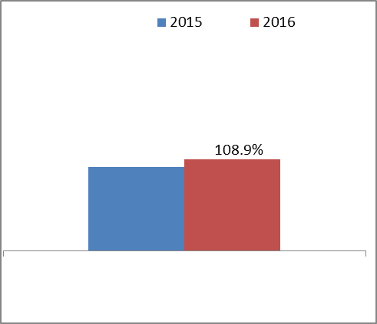

**Tax revenues and duties of the state budget of NKR for January-February 2016 in comparison with the planned index**

